**Module 6 : Data Management**

It is used to import/export bulk data to/from salesforce.

Export consists of:

1. Export
2. Scheduled export

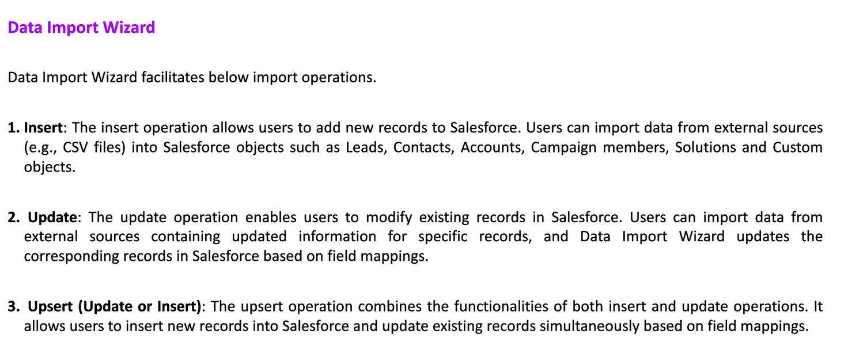

**Convert to csv file only then we can use it.**



